#### **Git Cherry Pick**

#### **Scenario:**

* You have two branches: branch-A and branch-B.
* You made a bug fix commit on branch-A that you now want to apply to branch-B without merging all changes from branch-A into branch-B.

#### **Steps:**

**Identify the Commit**:  
First, find the commit hash of the bug fix commit on branch-A:  
  
git log --oneline branch-A

1. Suppose the commit hash is abcdef1234567890.

**Switch to branch-B**:  
Ensure you are on branch-B where you want to apply the bug fix:  
  
git checkout branch-B

**Cherry-pick the Commit**:  
Apply the bug fix commit from branch-A to branch-B:  
  
git cherry-pick abcdef1234567890

1. This command applies the changes introduced by the commit abcdef1234567890 onto branch-B.

**Resolve Conflicts (if any)**:  
  
git cherry-pick --continue

**Commit the Cherry-picked Changes**:  
After resolving conflicts (if any), commit the cherry-picked changes on branch-B:  
  
git commit

1. This creates a new commit on branch-B that includes the changes from branch-A's selected commit.

**Git Stash**

#### 

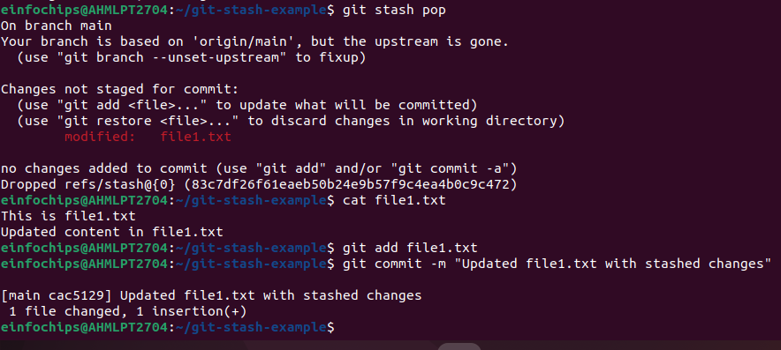

### **Docker Project 01**

#### **Project Overview**

In this project, you'll go through all three lifecycles of Docker: pulling an image and creating a container, modifying the container and creating a new image, and finally, creating a Dockerfile to build and deploy a web application.

### **Part 1: Creating a Container from a Pulled Image**

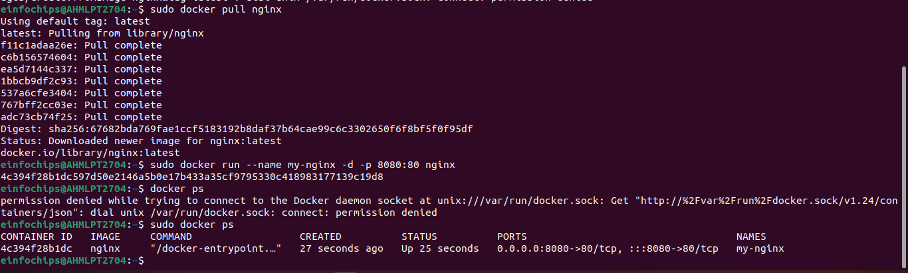

### **Part 2: Modifying the Container and Creating a New Image**

**Objective:** Modify the running Nginx container to serve a custom HTML page and create a new image from this modified container.

**Steps:**

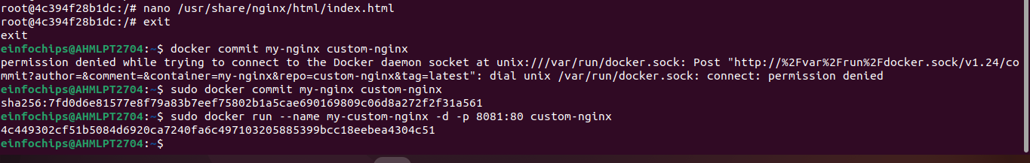

### 

### **Part 3: Creating a Dockerfile to Build and Deploy a Web Application**

**Objective:** Write a Dockerfile to create an image for a simple web application and run it as a container.

**Steps:**

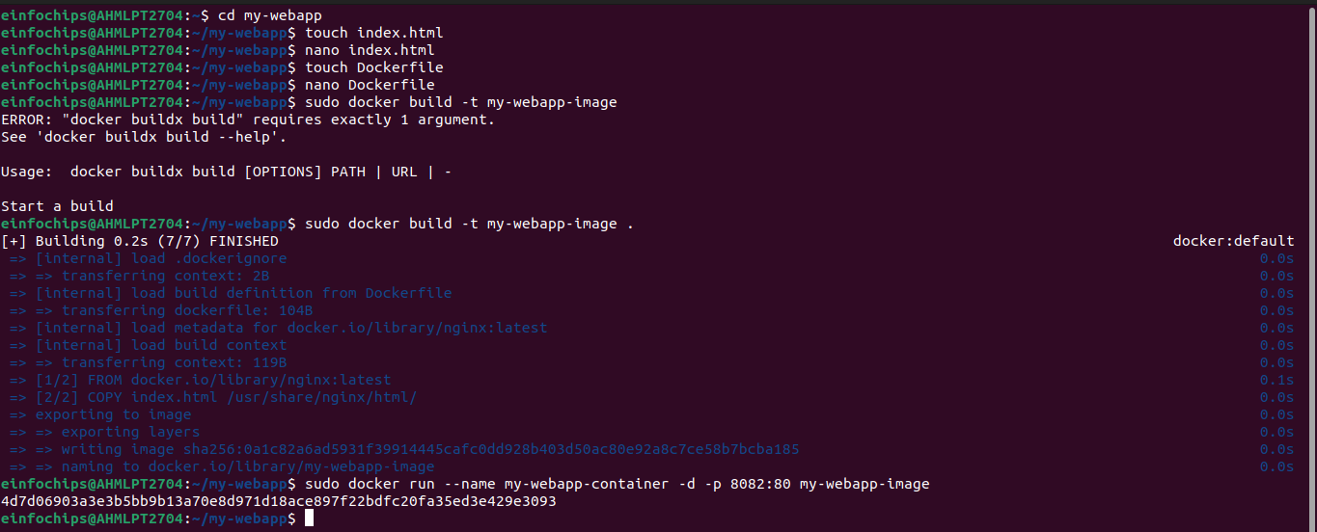

### 

### **Part 4: Cleaning Up**

**Objective:** Remove all created containers and images to clean up your environment.

**Steps:**

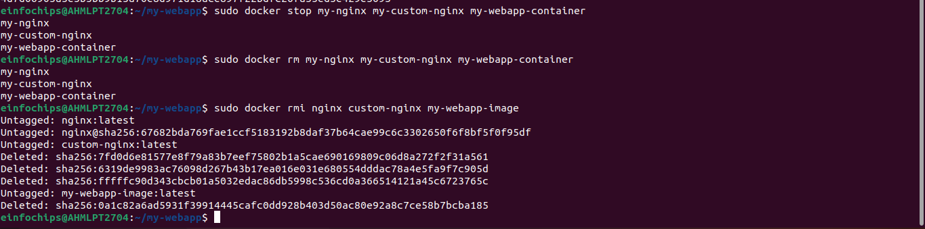

**Docker Project 02**

#### **Project Overview**

In this advanced project, you'll build a full-stack application using Docker. The application will consist of a front-end web server (Nginx), a back-end application server (Node.js with Express), and a PostgreSQL database. You will also set up a persistent volume for the database and handle inter-container communication. This project will take more time and involve more detailed steps to ensure thorough understanding.

### **Part 1: Setting Up the Project Structure**

**Objective:** Create a structured project directory with necessary configuration files.

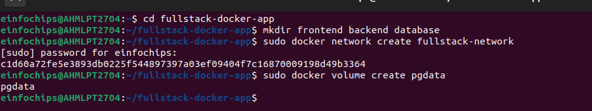

### **Part 2: Setting Up the Database**

**Objective:** Set up a PostgreSQL database with Docker.

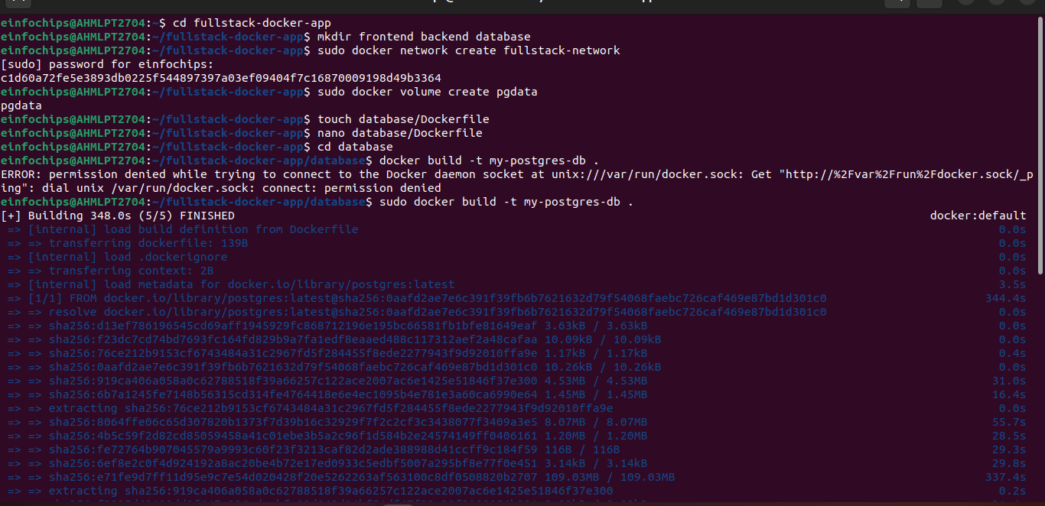

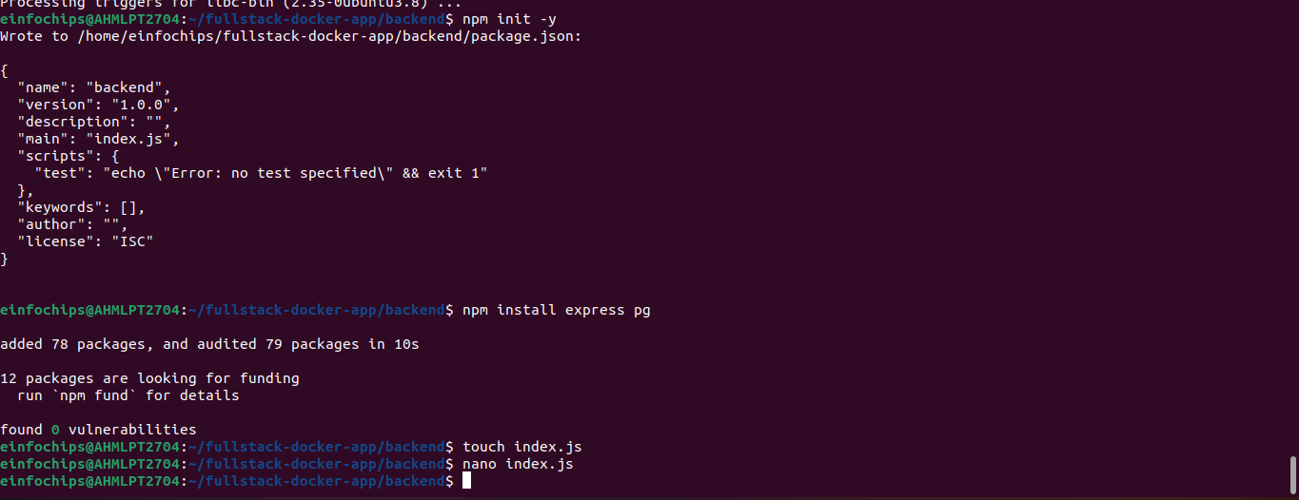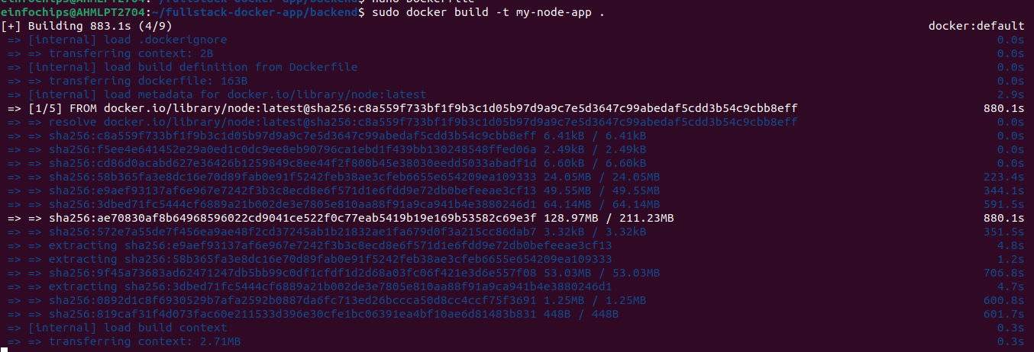



### **Part 4: Setting Up the Frontend (Nginx)**

**Objective:** Create a simple static front-end and set it up with Docker.

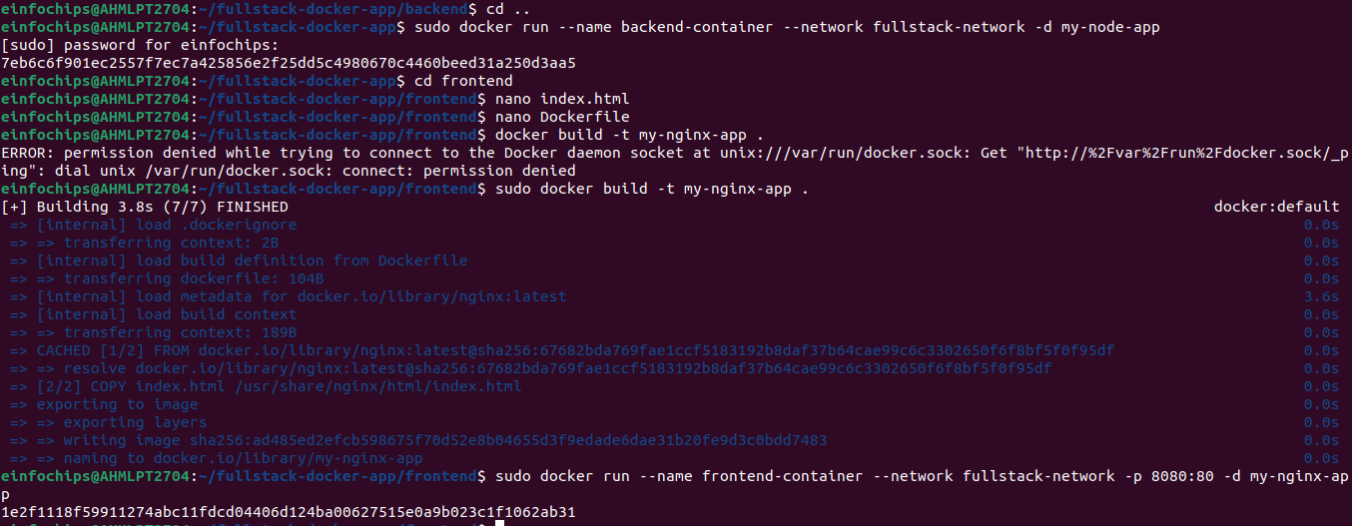

**Part 5: Connecting the Backend and Database**

**Objective:** Ensure the backend can communicate with the database and handle data requests.

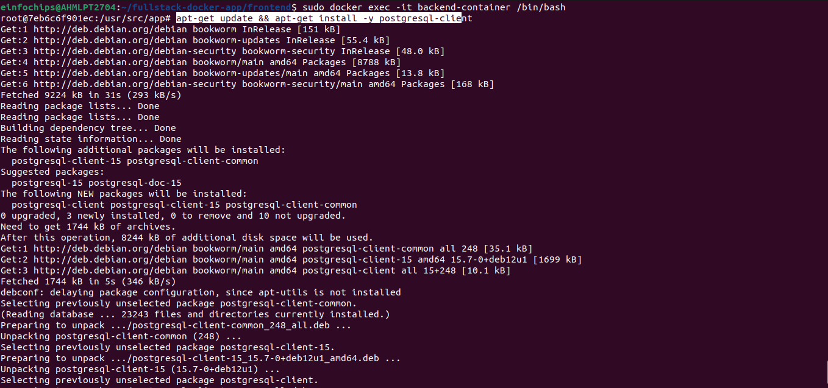

### **Part 6: Final Integration and Testing**

**Objective:** Ensure all components are working together and verify the full-stack application.

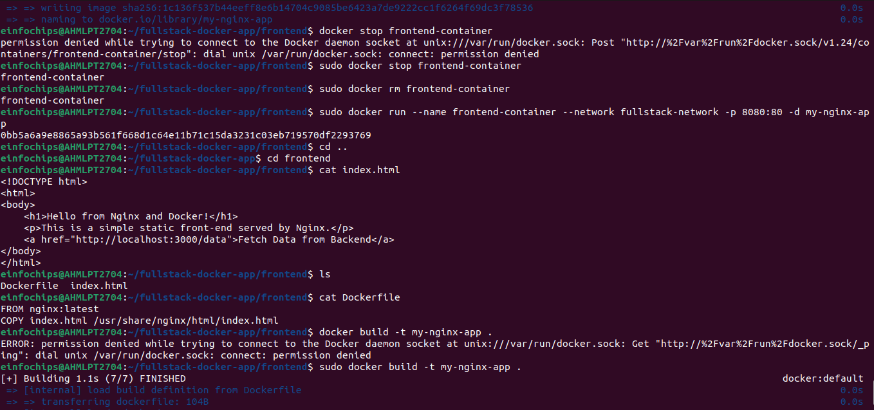

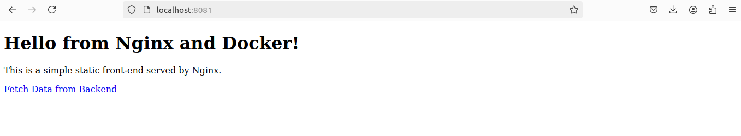

**Part 7: Cleaning Up**

**Objective:** Remove all created containers, images, networks, and volumes to clean up your environment.

